**ACC 2022 QUESTIONS**

1. A client has implemented a custom integer field in the nmsRecipient schema called Activity Rating. The field is populated during an  import process that runs highly. The ActivityRating can contain a value between 0 and 9. When targeting recipients it is common for the client to specify the ActivityRating should be between a range, for example between 2 and 5   
      
   What is a way to repeat this query?   
      
   A. A pre-defined filter   
      
   B. A target mapping   
      
   C. A topology rule   
      
   D. A split activity
2. competitors are signing up for a client’s email communication to gather intelligence on latest news and offers.

What should the developer do to make sure these emails do not go to the competitors?

A. Get a list of competitor domains   
create a control typology rule to exclude those domains   
add the rule to the typology

B. Get a list of competitor domains   
create a pressure typology rule to exclude those domains   
add the rule to the typology

C. Get a list of competitor domains   
create a capacity typology rule to exclude those domains   
add the rule to the typology

D. Get a list of competitor domains   
create a filtering typology rule to exclude those domains   
add the rule to the typology

1. When connecting to an Adobe Campaign server using the Client Console, an operator gets the following error: HTTP code 500 The IP address via accessing the server is not accepted. Connection refused."   
      
   How should the Developer fix this issue?   
      
   A. Configure a security zone for the operator to be able to connect   
      
   B. Uncheck the 'Disable account' option in the security settings of the operator   
      
   C. Provide the operator with the correct connection URL   
      
   D. Uncheck the option 'Forbid access from the rich client in the security settings of the operator
2. A client has an Adobe Campaign Classic instance that sends more than 2 million emails per month. Queries are starting to become slower especially queries on the tracking log or broad log. The Campaign Classic Developer needs to change the data purge settings for these two tables   
      
   Where should the Developer go to perform this task?   
      
   A. serverConf.xml   
      
   B. config instance-name> xml   
      
   C. External Accounts   
      
   D. Deployment Wizard
3. The control Panel will provide visual indications as the GPG key approaches its expiry date. It provides a warning (yellow) at 60 days before expiry date An urgetnt(red) is the final warning how many days before expiry does it appear?

A. 7

B. 30

C. 10

D. 14

1. A developer notices that there are several workflows all stuck in a "start as soon as possible" status. The developer checks the workflow heat map and do not see any spike in workflow activity.   
      
   What should the developer check next when troubleshooting this issue?   
      
   A. Conditional stop and Restart all the workflows that are stuck in a 'start as soon as possible" status   
      
   B. Stop all workflows with paused status to take less stress off the server so other workflows may run   
      
   C. Confirm Campaign jobs (operationMgt) workflow is running   
      
   D. Stop and Restart all the workflows that are stuck in a 'start as soon as possible" status
2. An Adobe Campaign and Analytics customer wants to capture any website visitors who start their online shopping checkout process but do not successfully complete the shopping experience and abandon their shopping cart before completion. The customer wants to use these website visitor details to create a remarketing solution to contact those visitors about their incomplete purchases.   
      
   Which Campaign capability should the developer recommend to address this need?   
      
   A. Landing page capture forms   
      
   B. External Signals   
      
   C. Experience Cloud Triggers   
      
   D. Marketing Workflows
3. An adobe campaign classic developer needs to create a new schema for a functional need with a unique ID.

Why should the developer create a new ID sequence for this new schema?

1. To avoid slow database performance
2. To avoid reaching limit of IDs
3. To avoid duplicating keys in the database
4. To avoid having same ID in different table
5. A customer needs to view a folder list of recipient profiles with their email, first name, last name and number of total subscriptions to identify the most intresteted persons for the services defined by the customer   
      
   What should the Campaign Classic Developer use to calculate and display the total number of subscriptions in the list of recipients in real time?   
      
   A. Data schema.method   
      
   B. Workflow activity   
      
   C. SQL function   
      
   D. Database field
6. A customer has a database of students that includes registration to the classes they are attending

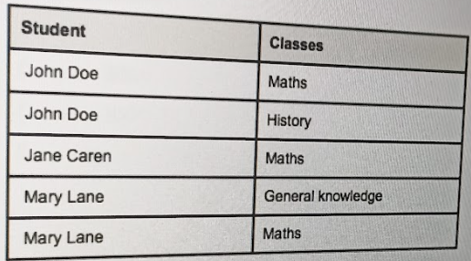

Given that students are considered recipients, which data model approach should the campaign classic developer use to save the navigation information

1. A data schema for classes linked to recipient schema
2. A many to many data schema between recipient and classes
3. Custom attributes in recipient schema for each class
4. a data schema for each class and linked to recipient schema
5. Review the following code

function nms_recipient_deleterecipient(id)

{

Xtk.session.Write(<nmsRecipient xtkschema= “nms:recipient” statusDelete=”1” -key=”@id” id=(id) -operation=”update”/>);

}

In which case this code is used?

1. JSSP call then update a recipient
2. SOAP call then update a recipient
3. JS workflow function then update a recipient
4. Javascript library then update a recipient
5. An Adobe Campaign Classic developer needs to add a method in a custom JavaScript library that retrieves a recipient custom string attribute called “costCenterName” based on the recipient’s ID

This method is expected to use extensively and will be called different places including SOAP calls and workflow.

What is the most performant way to write this code?

1. var query = NLWS.xtkQuerydef.create(   
   {queryDef:{ schema:”nms:recipient”,operation:”select”,   
   select:{   
   node:{expr:”@costCenterName”}   
   }   
   where:{   
   condition:{expr:”id=@123456”}   
   }   
   }})   
   var queryResult=query.ExecuteQuery();   
   var recipient=queryResult.getFirstElement(“recipient”),   
   if  (recipient != null){   
   var costCenterName = recipient.$ costCenterName;   
   }
2. var query = NLWS.nmsRecipient.load(123456);   
   var costCenterName = recipient.$ costCenterName;
3. var query = NLWS.nmsRecipient.get(123456);   
   var costCenterName = recipient.$ costCenterName;
4. Var recipientId=123456;   
   var costCenterName =sqlGetString(“select scostCenterName FROM Nms:recipeint WHERE iRecepientId=
5. In an Adobe Campaign v8 instance what field is needed for tables to replicate incrementally?
6. LastModified
7. InternalName
8. CreationDate
9. Label
10. A client wants to have available 20 new recipient custom fields that cannot be mapped to already existing fields in the recipient data schema. The requirement is such that these fields will be populated for 30% of the recipients. What is the recommended link cardinality between the recipient data schema and the custom data schema?
11. N-N
12. N-1
13. 1-N
14. 1-1
15. An Adobe Campaign Developer configured a SQL data management activity. How will the developer find the SQL name of the outbound worktable?
16. sql.tableName
17. task.tableName
18. activity.tableName
19. Sql.activityName
20. As a best practice to ensure good performance of the Adobe Campaign V8 solution , what is the data retention period for consolidated tracking ?
21. 9 months
22. 6 months
23. 1 year
24. 1 year 3 months
25. A customer has a custom CRM System that holds all profiles used for Marketing Campaigns. The customer we to have the data available in Adobe campaign Classic and use it for Marketing Campaigns. The CRM System is relying on HTTP communication to communicate with other system   
       
    In which two ways can the CRM System push profiles to Adobe Campaign Classic? (Choose two)
26. SOAP
27. External Account
28. REST
29. FTP/SFTP
30. Workflows
31. A customer needs to cancel a given Marketing campaign if at least one of the targeted profiles has no value for a personalization field used in the delivery.   
       
    This check must be done as close as possible to the actual sending for the whole targeted audience to be verified correctly for missing personalization   
       
    How should this requirement be implemented?
32. extra script in the delivery
33. DCE content for the delivery
34. filtering typology rule
35. control typology rule
36. An Adobe Campaign Classic Developer needs to provide the means for a back office in-house interface to leverage recipient subscription data stor Campaign's database in real time. The framework of the back office interface relies on simple system integration. ]   
    What customization should the Developer implement?
37. External accounts
38. Technical workflows
39. JSSPS
40. Methods in data schemas
41. A requirement exists to limit write access to a schema to only members of the built in Administrator operator group.   
       
    Which of the sysFilter configurations below will meet this requirement?
42. <sysFilter name="writeAccess">   
    <condition enabled if="hasNamed Right('admin')=false" expr="TRUE"/> </sysFilter>
43. <sysFilter name="writeAccess">   
    <condition enabled if="hasNamed Right('admin')=false' expr="FALSE"/> </sysFilter>
44. <sysFilter name="writeAccess">   
    <condition enabled if="hasNamed Right('admin)=true" expr="FALSE"/> </sysFilter>
45. In which two sections of the Control Panel can IP allow lists be set up? (Choose two.)
46. Instance Settings
47. Performance Monitoring
48. Subdomains & Certifications
49. SFTP Management
50. A Campaign operator was promoted and no longer requires access to Adobe Campaign Classic. The operator's account has been disabled, howev to receive alerts and notifications from Campaign.   
       
    What should the developer do to stop sending Campaign notifications to this operator?
51. Delete the operators profile from Adobe Campaign
52. Update the alert activities to a different operator group
53. Remove the email address from their profile
54. Update the access settings parameters under access rights
55. A customer located in Germany request that any Adobe campaign classic operator located outside of Germany should not be allowed to see recipient schema all operators that are not located in Germany have been assigned the name right of “OutsideCountry” which schema configuration  will hide the display of recipients last name for operator who are located out Germany ?
56. <attribute name = “lastName”  assessableIf = “HasNamedRight (‘OutsideCountry’) = true”/>
57. <attribute name = “lastName”  assessableIf = “HasNamedRight (‘OutsideCountry’) = false”/>
58. <attribute name = “lastName”  assessableIf = “HasNamedRight ==‘OutsideCountry’”/>
59. <attribute name = “lastName”  assessableIf = “HasNamedRight  !=‘OutsideCountry’”/>
60. An Adobe campaign V8 developer wants to update or delete data using API call.   
       
    Which API will the developer use?
61. xtk.session.ingestDelete
62. xtk.session.ingestWrite
63. xtk.session.ingest
64. xtk.session.ingestExt
65. An Adobe Campaign Classic developer is building a workflow to insert a customer's favorite music genre from a file collected by that ncritor an enrichment activity to reconcile the file data and recipient data, which allows them to use the file data to personalize deliveries  
    How will these personalization fields appear in the delivery content?  
    A. <%= recipient.FIELD %>

B. <%= targetData.FIELD %>  
C. <%= temp.FIELD %>  
D. <%= tempTableName.FIELD %>

1. A client asks an Adobe Campaign Classic Developer to set up a workflow that imports customer data. This data will core from an S3 bucket. The migort rout. num daily. The records must be stored in an existing Campaign table.  
   Which sequence of workflow activities should the Developer use?  
   A.Scheduler, File collector, Data extraction, Update data  
   B.Scheduler, File transfer, Data extraction, Update data  
   C.Scheduler, File transfer, Data loading. Update data  
   D. Scheduler, File collector, Data loading, Update data
2. A customer has an in house crm application that needs to get create an update and delete custom data stored in adobe campaign classic connection what are the 2 minimum prequistes  for the CRUD you do opera to work?
3. Whitelist crm applications server ip
4. Configure ip affinity
5. Authenticate as a technical operator with appropriate rights
6. Call QueryDef methods
7. Create a request from adobe campaign classic to the crm applications
8. A client requirement is to download a CSV file from an AWS S3 bucket on a scheduled basis and to process the contents from the file to update a custom Schema in Adobe Campaign Classic instance.

Which component should be used to implement the AWS S3 connection?

1. External account
2. JavaScript activity
3. JSSP
4. FDA connector
5. An Adobe Campaign Classic developer is working on an import workflow. The format of the file to be imported is CSV. An aggregate must be computed in the workflow.

Which three components should be used to implement the import workflow? (Choose three)

1. [] update data
2. [] change dimension
3. [] enrichment
4. [] data loading
5. [] list update
6. [] query
7. A Customer has an internal sales application that needs to create, update and delete records to and from Adobe Campaign Classic. The application communicates in real time with Adobe Campaign Classic.

Which customization should be used to implement the simple CRUD operations?

A) Data Schema attributes

B) SQL script to query and update data

C) Workflow with query and update activities

D) Data Schema Methods

1. A client is providing a new file that must be loaded into Adobe Campaign Classic. The file contains data in XML format, that will be sent daily and contains approximately 5k records per file.

What activity should be used to import this file?

A) Loading (SOAP)

B) import

C) JavaScript code

D) Data Loading (file)

1. An Adobe Campaign Classic Developer investigating why bounces are no longer being forwarded on a campaign instance even though emails are being sent.

Which process should the developer investigate further?

A) mta

B) trackinglogd

C) stat

D) inMail

1. And Adobe campaign classic instances slow several workflows are scheduled the developer want to use a heat map to analyse the performance of the campaign instance what are 3 reasons to use heat map to analyse the performance of the campaign instance ?
2. Look for a specific workflow to analyse
3. Make a report of the workflow
4. Easily check the workflow with signals
5. Filter workflows by duration to see which workflows may encounter issue
6. See and understand concurrent workflows
   1. A developer needs to send an alert for a technical workflow when there are no records to load.

How would the developer do this?

A) vars.recCount>0

B) vars.transCount>0

C) vars.Count>0

D) vars.activityCount>0

* 1. An Adobe campaign developer identifies that click and open data has not been updated in several days.

Which OOTB technical workflow should be checked while troubleshooting this issue?

1. Task notification (taskMgt)
2. Tracking (tracking)
3. Update event status(updateEventStatus)

* 1. A Developer wants to send an alert to an operator that will contain the name of profiles who opened the newsletter but did not contain the link it contains. The profile’s first and last name fields are linked to the recipients targeting dimension, whereas the alert activity is linked to the operator targeting dimension. As a result, there is no field available between two targeting dimensions to perform a reconciliation and retrieve the first and last name fields, and display them in the alert activity.

What activities would the developer need to build out this notification?

1. Query > JavaScript Code > Test > Alert
2. Query > JavaScript Code > Alert
3. Query > Enrichment > Test > Alert
4. Query > Test > Alert
   1. In Adobe campaign V8 instance data from building tables is not being replicated to the snowflake database and it should be  what OOTB  workflow should the developer  look at while troubleshooting this issue ?
5. Replicate reference tables (fda ReplicateReferenceTables)
6. Replicate All data(fda ReplicateAllData)
7. Replicate Staging data(fda ReplicateStagingData)
   1. Consider the code below:  
      var query = NLWS.xtkQueryDef.create({queryDef: {  
      schema: 'nms: recipient’,  
      operation: ‘select’,  
      select: {node: [  
      {expr:’@firstName’),  
      {expr:'@lastName’),  
      {expr:'@email’)  
      ]},  
      where: {condition: [

{expr;”@domain = 'nydomain.com'”}  
]},

}});  
var results= query.ExecuteQuery( ).getelemen sByTagname("recipient”);  
Which code should be created for logging out the First Name, Last Name, and email address of each record to the workflow Audit log?  
A. for (var i = 0;i < results. length; int)  
logInfo(results[i].$first Name);  
logInfo(results!i].$lastiame);  
logInfo(results[f].$email);

B. for (var i = 0;i ‹ results.query. length; i++)  
logInfo(results[d].$firstName);  
logInfocresults[I].$lastName);  
logInfo(results[1].$email);

C. for (var i = 0 ;i < query. length;i++)  
 logInfo(query[il.$firstName);  
 logInfo(query[i].$lastName)  
 loginfo(query[i].$email);

D. for (var i = 0;1 ‹ query.results.length; i++)  
 logInfo(query[i]-$firstname);  
 logInfo query [i]-$lastname)  
 logInfo(query[i]. $email);

* 1. An Adobe Campaign Classic developer has a use case to retrieve data from multiple tables and insert data into the temp table within a workflow to  personalise downstream deliveries. Which 2 methods should be used to perform this requirement within a JavaScript activity ?(choose 2)

1. Xtk.queryDef.Update()
2. Xtk.queryDef.create()
3. Xtk.session.write()
4. Xtk.workflow.execute()
5. Xtk.workflow.postevent()

40. What is a use case for a custom target mapping when implementing Adobe Campaign Classic?

A. Store the address in an Individual table

B.Include seed addresses in the delivery

C.Retarget based on segment code

41. A customer asks an Adobe campaign classic developer to develop a workflow that runs daily at 4:00 PM the workflow contains a JavaScript code activity if an error occur a new record should be created in a custom error table and an alert activity executive which 2 fields  in the JavaScript code activity should be filled in? (choose 2).

1. Script
2. Process errors
3. Behaviour
4. In case of error
5. excution

42. Review this targeting workflow and Exclusion activity configuration:

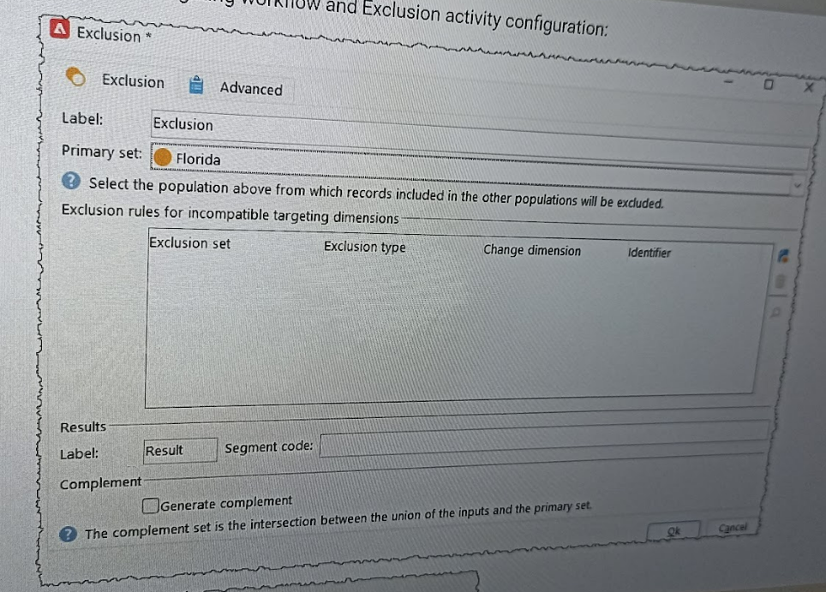

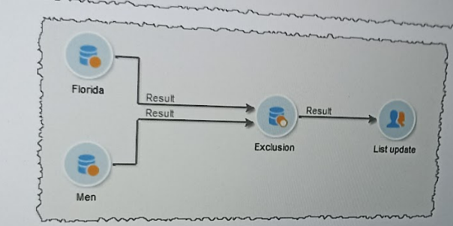

What resulting data will be passed to the List Update Activity?

1. All men living in Florida
2. All recipients living in Florida who are not men
3. All men who do not live in Florida

43. In the targeting workflow below, recipients are uniquely filtered based on living in Ohio and being 18-25 years old.

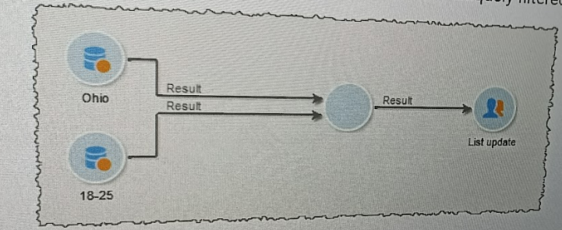

What Adobe Campaign activity type would be used to ensure the list is updated with only those recipients 18-25 years old that live in Ohio?

1. Intersection
2. Union
3. AND-Join

44. An Adobe Campaign Classic developer needs to follow best practices on Adobe Campaign Classic workflow implementation.

Which three options should the developer select to keep the overall system in healthy status? (Choose Three)

1. Avoid leaving workflows in a paused state
2. Restart recurring Campaign workflows on a weekly basis
3. Do not schedule workflows to run more than every 15 minutes
4. Use production severity option on production workflows
5. Purge logs when they are not needed anymore
6. Check ‘Keep Interim Results’ option in a workflow property

45. An Adobe campaign developer needs to insert a JavaScript activity that will be used to query the temp table in a workflow. How should the developer verify the name of the temporary schema at the point of the  JavaScript actually?

1. Display the target and click the schema tab
2. View the targeting dimension for the workflow
3. Check variable tab within the workflow properties
4. Use loginfo in the js activity

46. A customer requests an automated process to send event notifications every 15 minutes to a large group of users who are targeted as event participants. All notifications must be sent before sending the next batch of notifications. No user should receive the same notification twice What activities should the Adobe Campaign Classic developer use in the Campaign workflow to meet these requirements?

A.Scheduler and Test activity before targeting that leverages the last run of the workflow as an option

B.Wait activity and Test activity after targeting that leverages the last run of the worklow as an option

C.Wait activity and Test activity before targeting that leverages the last run of the workflow as an option

D.Scheduler and a Test activity after targeting that leverages the last run of the workflow as an option

47. A campaign Classic developer wants to monitor which variables are being passed through a workflow to begin debugging a JavaScript activity. To begin, the developer needs to see all the eventVariables available at each stage of the workflow by task.

When executing the workflow, which action should the Adobe Campaign Classic developer take to show the eventVariable that are being passed throughout the workflow?

1. Display progression information
2. Keep the result of interim populations between the two executions
3. Audit message in the journal
4. Display the tasks and log

48. A client requested additional meta data be captured in the broad Log.

Where does the developer need to go to configure the additional attributes, so they are automatically captured at the time of send?

1. Extend Schema
2. Target Mapping
3. Target Data
4. Delivery Activity

49. What is the maximum recommended number of simultaneous workflows that should be executed in an Adobe Campaign instance?

1. 10
2. 50
3. 20

50. An Adobe Campaign Classic Developer’s client uses a unique customer ID to identify and contact their customers. This customer ID is a number. The client wants to send out a personalized email to all customers.

What Exclusion setting can have a different impact if the ID would have been an email instead of number?

1. Recipients who no longer wants to be contacted
2. Previously contacted recipients
3. Quarantined recipients
4. Duplicate addresses during delivery